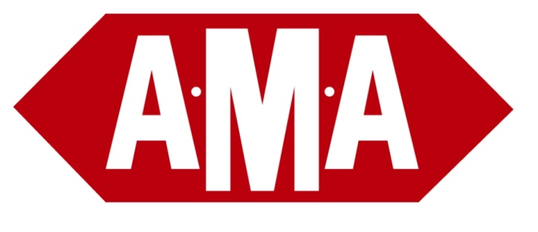
Emergency Plans

To all customers,
Due to the Covid 19 pandemic, we have heard from many customers and consignees that they are concerned about handling paperwork. In regard to this and the potential exposure involved, we are implementing a new plan to eliminate the risk, as follows:

When making delivery, if the consignee or driver feels that it is safer to REFRAIN from signing the DR copy, the driver can then print the name of the receiving person on the DR. The driver may also take a picture of the shipment at the delivery location to demonstrate that the product was physically delivered.

This plan will act as the official signature of receipt and will absolve AMA from the liability of the physical receivers signature on receiving documents in accordance with previous practices.

Please know that this is an emergency plan that has been invoked to reduce exposure out of concern for all personnel, the general public, as well as customer safety.

This communication acts as a document. We will automatically assume that this emergency process will be agreed upon by all customers and consignees.

In the absence of hearing back from a customer who cannot agree to this emergency plan, we will commence handling the signature requirement as stated above.

Thank you for your understanding and support.

Please practice best health and sanitary processes. Stay safe and healthy, as we unite to fight this disease.

Sincerely,
The Bruzzese Family & AMA Operations Managers

